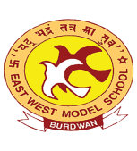
EAST WEST MODEL SCHOOL
TALIT, PURBA BARDDHAMAN
PIN-713141
Annual Sports

Annual Sports of East West Model School will be held on 29th January 2026 (Thursday).

Important Instructions/Information
1. Dress: House Jersey, House Track Pant, and White Sports Shoes (for Heat & Final)
2. Violation of instructions regarding prescribed uniform will invite disqualification from participation in any event.
3. Bus service will be available only for the students on the Sports Day (29th January, 2026).
4. Parents may come to school arranging their own transport to encourage their wards participating in any event.
5. On 29.01.26 (Thursday) the School Bus shall follow morning section time and day section route
(Keep in touch with Bus Driver/Conductors)

TIME OF ARRIVAL:
8:30 A. M.
TENTATIVE TIME OF DISPERSAL:
02:30 P. M.

Rector
EWMS

